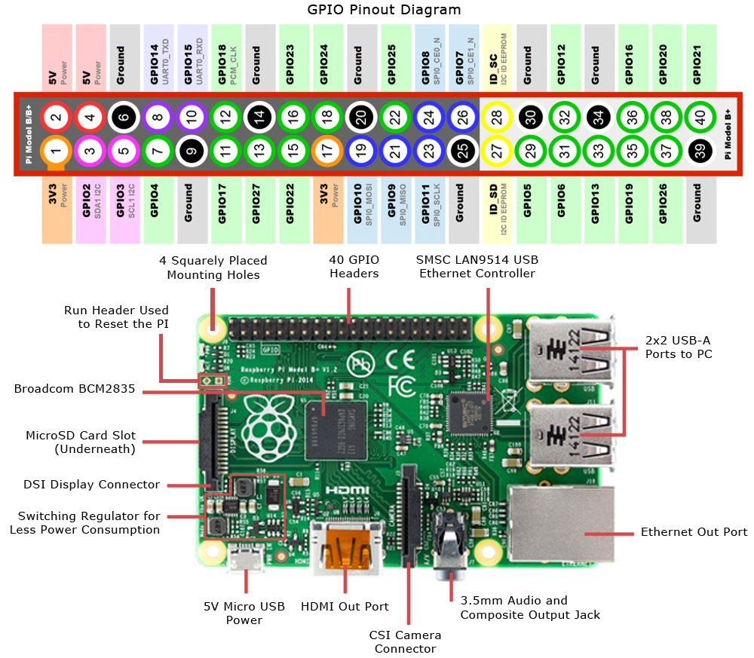

|  |  |  |  |  |  |
| --- | --- | --- | --- | --- | --- |
| Pin Out Table (ordered by components – Motor, Ultrasound, I2C, Vin, Radio) | | | | | |
| Servo Ail Left | GPIO 17/ pin11 | 3.3V I2C | Pin 1 | Vin 5V | Pin 2 |
| Servo Ail Right | GPIO 22/ pin15 | GND I2C | Pin 14 | GND 5V | Pin 6 |
| Servo Rudder | GPIO 24/ pin18 | SCL I2C | GPIO3/ pin5 | CE | GPIO25/pin22 |
| Servo Elevator | GPIO 5/ pin29 | SDA I2C | GPIO2/ pin3 | CSN/CS | GPIO8/ pin24 |
| ESC | GPIO 21/ pin40 |  |  | SCK | GPIO11/pin23 |
| GPIO - Trig | GPIO 19/ pin35 |  |  | MOSI | GPIO10/pin19 |
| GPIO - Echo | GPIO 26/ pin37 |  |  | MISO | GPIO9/pin21 |
| 5V Ultra Sound | Pin 4 |  |  | 3.3V rad | Pin 17 |
| GND ultrasound | Pin 9 |  |  | GND rad | Pin 20 |

Pin Out Table (Order by pin number)

|  |  |
| --- | --- |
| Item | Pin (in order) |
| 3.3V I2C | Pin 1 |
| Vin 5V | Pin 2 |
| SDA I2C | GPIO2/ pin3 |
| 5V Ultra Sound | Pin 4 |
| SCL I2C | GPIO3/ pin5 |
| GND 5V | Pin 6 |
| GND ultrasound | Pin 9 |
| Servo Ail Left | GPIO 17/ pin11 |
| GND I2C | Pin 14 |
| Servo Ail Right | GPIO 22/ pin15 |
| 3.3V rad | Pin 17 |
| Servo Rudder | GPIO 24/ pin18 |
| MOSI | GPIO10/pin19 |
| GND rad | Pin 20 |
| MISO | GPIO9/pin21 |
| CE | GPIO25/pin22 |
| SCK | GPIO11/pin23 |
| CSN/CS | GPIO8/ pin24 |
| Servo Elevator | GPIO 5/ pin29 |
| GPIO - Trig | GPIO 19/ pin35 |
| GPIO - Echo | GPIO 26/ pin37 |
| ESC | GPIO 21/ pin40 |